[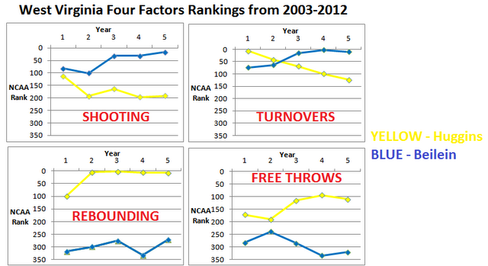](http://1.bp.blogspot.com/-nU-WNSFXj6M/T7hnXa2cjjI/AAAAAAAAAN8/U0T2jvBsW84/s1600/westvirginia4f.png)